

**Faculty of Science**

**Department of Computer science**

**University of Ruhuna**

**PROJECT REPORT**

**Website of Medical Center**

|  |  |
| --- | --- |
| SC/2018/10657 | K.D.Thenuwara |
| SC/2018/10660 | M.C.Manage |
| SC/2018/10664 | A.N.D.Weerathunga |
| SC/2018/10665 | K.P.M.N.Samaranayaka |
| SC/2018/10668 | M.N.F.Naleema |

**Group No. - 02**

**Contents**

**1** **Introduction** 2

**1.1** **Method** 2

**1.2** **Findings** 2

**2** **Design** 3

**3** **Implementation** 3

**4** **Technical Platform** 4

# **Introduction**

The Medical Center website report covers the details and planning of the project of Medical Center Website. The project is aimed at developing a website that depicts a complete information about the Medical Center of the University of Ruhuna to the users. In addition, the website has been added the information about the Ayuruwedic Medical Center, which is provide services for the university students and the staff. Using this website, the users can easily get details about the Medical Center and get a knowledge about how to register for the Medical Center and the services they are providing for get the medical services. The website has been included a register form to register directly to the Medical Center.

## **Method**

The data was gathered from three primary sources. Firstly we collected the basic information from the chief medical officer of the main Medical Center and then from the doctor of Ayuruwedic Medical Center. After all, we studied about the current medical center website of Ruhuna of University and the other university medical center websites for get some idea. After collecting all the facts, we made a simple structure for the site we are going to create.

## **Findings**

While creating our website we got a number of suggestions for improvement. The main things we had to improve was giving such impression to the user by adding different features. Also, we were advised to change the appearance of the web pages.

# **Design**

In the website, we added several tabs as usual other websites. There is a simple introduction about the medical center in the main page. And also, we added some pictures with medical advices. The user can access to the homepage from a tab directly.

We have added 6 tabs for the website. Those are divided for the convenience of the user.

The six tabs are,

* HOME
* REGISTRATION
* STAFF
* FACILITES
* ABOUT US
* CONTACT US

The Facility tab has several sub contents, which show the services provide by the medical center such as Pharmacy, Laboratory services etc.

# **Implementation**

The data here is a collection of everything we have been discovered, not a to-do list of the items we will be implementing.

**Step 01 - Gathering Information**

* Set goals for the website

Step 02 - Planning

* Create a structure
* Select technology stack

**Step 03 - Design**

* Create basic of web pages
* Change the appearance when required

**Step 04 - Coding**

* Add collected facts regularly
* Add Special Features

**Step 05 – Testing and Review**

* Test the created website
* Fix the errors
* Finishing
* Make the report

# **Technical Platform**

Web development comes with a huge set of rules and techniques every website developer should know about. When we creating our website we mainly used three languages.

* HTML
* CSS
* JAVASCRIPT

**1. Browsers**

Browser requested to show us the website in the way we can understand. Mostly we used Google Chrome to test our website clearly.

**2. HTML & CSS**  
HTML is the main language we used to code & create the website content.

CSS stands for Cascading Style Sheets and it describes how HTML elements are to be displayed on the screen. Those ones are the main parts of the created website.

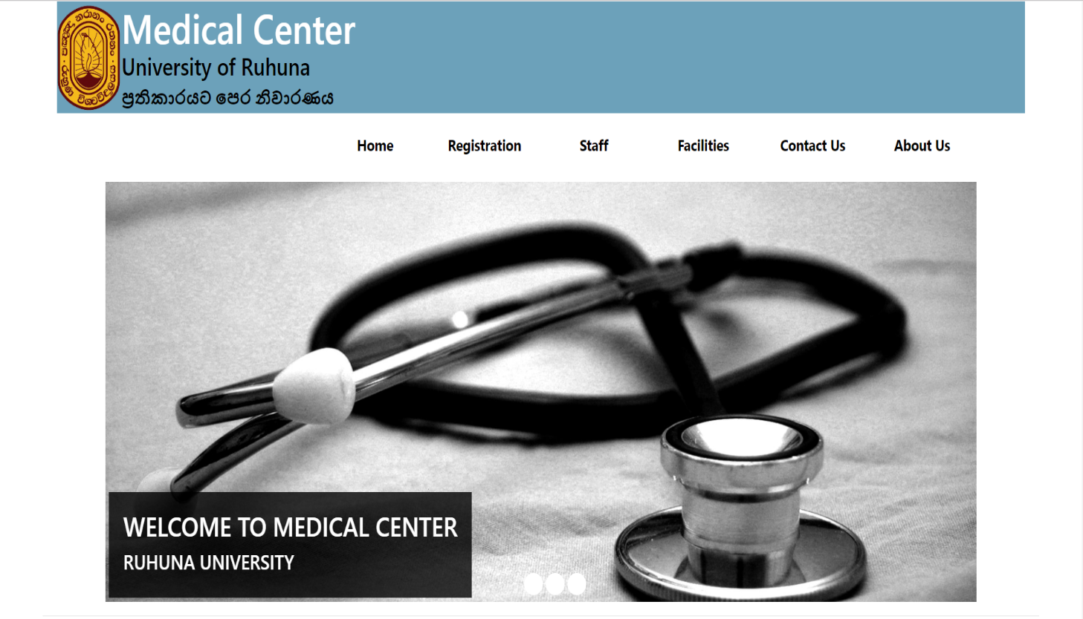**Screenshots**

